Practical No:3
Part-A
Programming Mitsubishi Industrial Robot (SCARA) using teach pendant
Theory
Objective:
The objective of this experiment is to demonstrate how to program a Mitsubishi industrial robot using the teach pendant
Materials:
- Mitsubishi industrial robot
- Teach pendant
- Workstation or table
- Safety equipment (gloves, safety glasses, etc.)
Explanation of functions:
Operation panel (O/P) functions
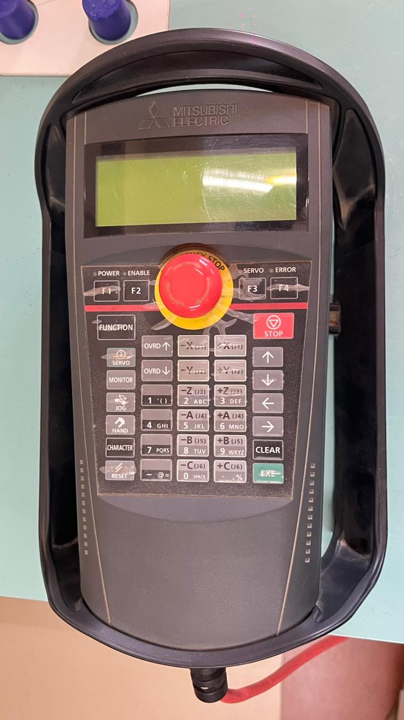

(1) Description of the operation panel button

1. START button. This executes the program and operates the robot. The program is run continuously.
2. STOP button- This stops the robot immediately. The servo does not turn OFF.
3. RESET button-This resets the error. This also resets the program's halted state and resets the program
4. CHNG DISP button.- This changes the details displayed on the display panel in the order of "Override" "Program No." "Line No."
5. END button-This stops the program being executed at the last line or END statement
6. SVO.ON button - This turns ON the servo power. (The servo turns ON.)
7. SVO OFF button This turns OFF the servo power. (The servo turns OFF)
8. STATUS NUMBER (display panel) - The alarm No., program No, override value (%), etc, are displayed
9. UP/DOWN button - These scrolls up or down the details displayed on the "STATUS NUMBER" display panel

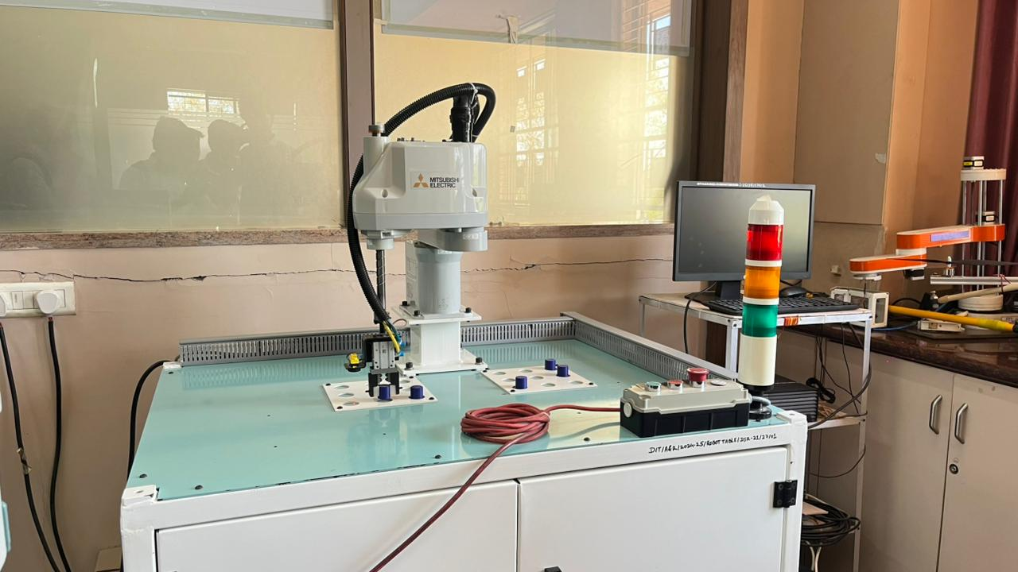
Scara Robot fig.1
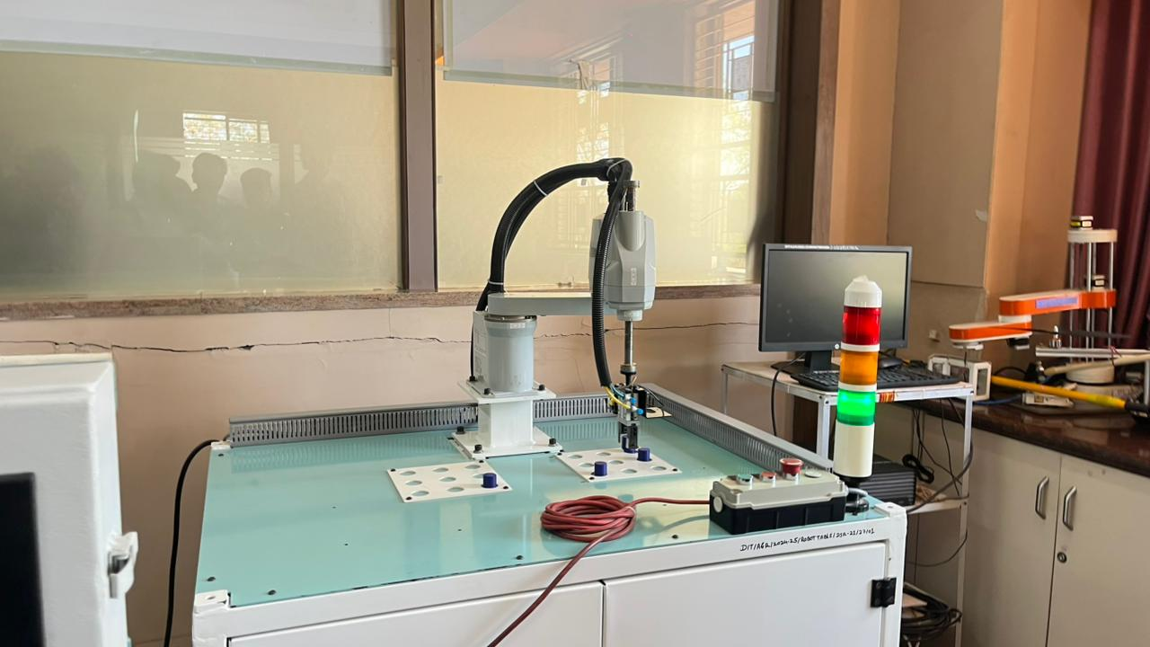
Scara Robot fig.2

Conclusion:
Programming a Mitsubishi industrial robot using the teach pendant can be a simple and effective way to automate simple tasks. It is important to keep safety in mind when working with industrial robots and to follow all safety guidelines provided by the manufacturer

